**Chapter 3: Elicitation**

After discussing on inception part, we need to keep focus on the elicitation part. So this chapter specifies the elicitation part.

## **3.1 Introduction**

Requirements elicitation is a part of requirement engineering that is the practice of gathering requirements from the users, customers, and other stakeholders. We have faced many problems like understanding the problems, problems of making questions for the stakeholders, problems of less communication with the stakeholders for time limitation, problems of volatility. Though it is not too easy to gather requirements within a very short time, we have surpassed these problems in an organized and systematic manner.

## **3.2 Eliciting Requirements**

Inception where Question and Answer approach is used; elicitation makes use of a requirements elicitation format that combines the elements of problem solving, elaboration, negotiation, and specification. It requires the cooperation of a group of end-users and developers to elicit requirements .To elicit requirements we completed following four works.

* Collaborative Requirements Gathering
* Quality Function Deployment
* Usage Scenarios
* Elicitation work products

### **3.2.1 Collaborative Requirement Gathering**

Many different approaches to collaborative requirements gathering have been proposed. Each makes use of a slightly different scenario .We completed following steps

* The meetings were conducted with the students and discussed with teachers and professionals. They were questioned about their requirements and expectations from the Graduate record verification system
* They were asked about their Graduate record verification system problems.
* At last we selected our final requirement list from the meetings.

### **3.2.2 Quality Function Deployment**

Quality function deployment (QFD) known as a way to represent the “voice of the customer,” is a process for capturing customer requirements and translating them into requirements that can be used by designers, producers, and suppliers. It concentrates on maximizing customer satisfaction from the Software engineering process .With respect to our project the following requirements are identified by a QFD.

**3.2.2.1 Normal Requirements**

Normal requirements consist of objectives and goals that are stated during the meeting with the customers. Normal requirements of our project are:-

1. Allow valid user to login and logout
2. Check user validity
3. Feature that will allow dynamic report generation
4. Allow users to generate academic transcript and certificate
5. Efficient and user friendly
6. The user interface of the system would be easy
7. Allow user to view approval of the admin panel
8. Allow user to give approval/rejection (by registrar)
9. Allow user to search Information of students
10. Allow user to track information by using activity log
11. Security issue
12. Error free activity

**3.2.2.2 Expected Requirements**

These requirements are implicit to the system and may be so fundamental that the customer does not explicitly state them .Their absence will be a cause of dissatisfaction. These are –

1. The application shall allow the user to log in based upon a user id and password.
2. The application shall automatically save the current date.
3. The application will allow the users to search, update or delete.
4. The user interface of the system shall be easy to use and shall make the least use of typing by users.
5. The application shall be easily maintainable.
6. The application will be stable.
7. The application will be open for future extension and modification.
8. All the records will be saved to database for future references.
9. The application shall be user friendly
10. The user interface shall make use of input such as drop downs, check boxes and radio buttons as much as possible to avoid invalid and incorrect input.

**3.2.2.3 Exciting Requirements**

These requirements are for features that go beyond the customer's expectations and prove to be very satisfying when present. These are

* 1. The system will enable the user to change user passwords if they forget old ones.
  2. The user interface should provide appropriate error messages for invalid input as well as tool-tips
  3. The system will have activity log for tracking information.

## **3.3 User Scenario**

Graduate Record Verification System

This system will be used for validating graduate students of Institute of Information Technology of University of Dhaka. Here the end users are UGC staffs (Admin, Staff 1, Staff 2), University staffs (Registrar, Data entry operator 1, Data entry operator 2), Graduate students, Stakeholders (Foreign universities, Employers), Payment processing partners.

System admin can add information (name, email address, mobile number, password, and role) about Admin, Registrar, Program officer of Institute/Department, Students, Stakeholder and assign their roles (Admin, Registrar, Program officer of Institute/Department, Students, Stakeholder). System admin can do all operations those defined for other users.

System admin can view activity log, generate report of all things. Activity log keeps track of information change.

(Student profile information depend on Registrar input) Student can log in to the system with his/her email address, password, and registration number. After logging in into the system, he/she can view his/her profile with personal information, academic information, and payment request from stakeholders. Personal information are name, email address, mobile number, present address, permanent address. Academic information are registration number, session, year, institute/department, university name. If any payment request is received, then he/she can pay through external system (PayPal). Response from external system will be recorded in database. Student can edit his/her personal information.

UGC staff can login into the system with email address, password. He/she can add university (name, location, website), university’s registrar with his/her information. UGC staff can generate report with all information (University wise, payment wise).

Registrar will login into the system with his/her email address and password. In Registrar profile, he/she can view his/her personal information (Name, designation, university name), add, edit and delete student information, and add digital signature to verify graduate student information, which are pending for approval. Registrar can generate reports that belong to his/her university.

Institute/Department program officer login into the system with email address, password. In PO profile, he can view his personal information. PO can define number of semester, add course in corresponding semester. PO can insert, update and delete students’ semester wise course results. PO can generate reports that belong to his/her institute/department.

Foreign universities or employers can access the system to validate their candidate students’ information. First, they have to enter student’s name, registration number, university name, mobile number and email address. If students’ information is available in the system, then stakeholder need to provide his/her credentials- name, designation, organizations’ name, contact number and email. After inserting that information, a request will be sent to the corresponding student as a payment request. If the payment is completed, a notification will be sent to Registrar to attach digital signature (signature image) to verify that student’s information. After completing verification, a link will be sent to stakeholders’ email address. Through this link, stakeholder get student has verified information.

## **3.4 Conclusion**

Elicitation phase helped us to understand about the problems of our scopes of the system. This phase also helped us to identify the requirements, negotiate different approaches and specify a preliminary set of solution requirements in an atmosphere that is conducive to the accomplishment of the goal.

# Chapter 4: Scenario Based Modeling

This chapter describes the scenario based model.

## 4.1 Definition of Use case

A use case captures a contract that describes the system behavior under various conditions as the system responds to a request from one of its stakeholders. In essence, a use case tells a stylized story about how an end user interacts with the system under a specific set of circumstances. A use case diagram simply describes a story using corresponding actors, who perform important role in the story and makes the story understandable for the users. The first step in writing a use case is to define that set of “actors” that will be involved in the story. Actors are the different people that use the system or product within the context of the function and behavior that is to be described. Actors represent the roles that people play as the system operators. Every user has one or more goals when using system.

Primary Actor: Primary actors interact directly to achieve required system function and derive the intended benefit from the system. They work directly and frequently with the software.

Secondary Actor: Secondary actors support the system so that primary actors can do their work. They either produce or consume information.

## **4.2 Use Case Diagrams**

Use case diagrams give the non-technical view of overall system.

### **4.2.1 System Description from Level-0 use case:**

After analyzing the user-scenario we found five actors who will directly use the system as a system operator. Primary actors are those who will play action and get a reply from the system whereas secondary actors only produce or consume information.

They all will be our users, who will be using our system to fulfill their procedures.

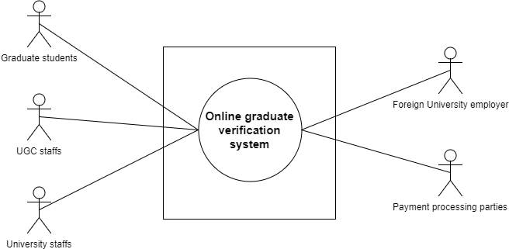

Figure 1: Level-0 Use Case Diagram

### **4.2.2 System Description from Level-1 use case:**

Primary Actor : User

Secondary Actor : System

Goal in Context : To operate the application.

Scenario : The actors of our system have to play different actions and system will reply according to these actions –

Action 1: Enters signup.

Reply 1: Please fill up the required information.

Action 2: Enters the information

Reply 2: Registration successful.

Action 3: Enters username and password.

Reply 3: Sign in successful and shows User Dashboard.

Different user’s action and reply (UGCs, Student, Registrar, Foreign University, Program Officer)

Action: Click add University (UGCs)

Reply: University added (UGCs)

Action: Click add Registrar (UGCs)

Reply: Registrar added (UGCs)

Action: Click add student (Registrar)

Reply: Student added (Registrar)

Action: Click add department (Registrar)

Reply: Department added (Registrar)

Action: Request for student verification (Foreign University)

Reply: Student verified

Action: Click to view student info (Student)

Reply: Show students details information (Student)

Action: Check payment request (Student)

Reply: Show the availability of the request (Student)

Action: Enter report generation (PO, UGCs)

Reply: Report generated (PO, UGCs)

Exception: No Exceptions (if system works correctly by fulfilling requirements)

Exceptions (if) : User is not authenticated.

: System error.

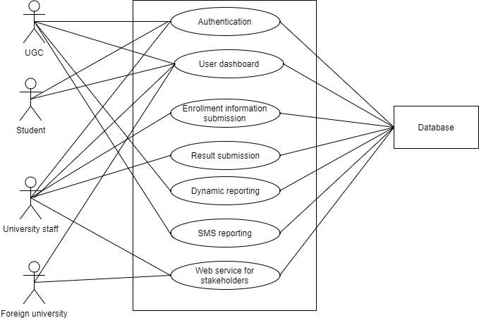

Figure 2: Level-1 Use Case Diagram

### **4.2.3 System Description from Level-1.1 use case:**

Action 1:

* Enters First Name
* Enters Last Name
* Enters email.
* Enter password
* Clicks on **Save.**

Reply 1: Successfully saved.

Action 2: Enters **Change Password.**

Reply 2: Prompts for enter previous password.

Action 3: Enters previous password.

Reply 3: Prompts for new password.

Action 4:

* Enters new password.
* Re-enters new password.
* Enters **Save Changes.**

Reply 4: Password successfully changed.

Action 5: Enters sign out.

Reply 3: Logged out user.

Exception: No Exceptions

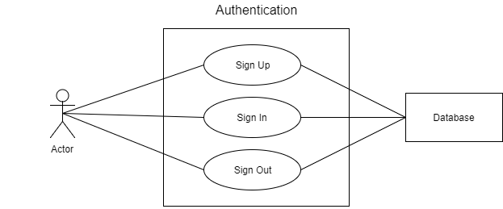

Figure 3: Level-1.1 Use Case Diagram

### **4.2.4 System Description from Level-1.1.1 use case:**

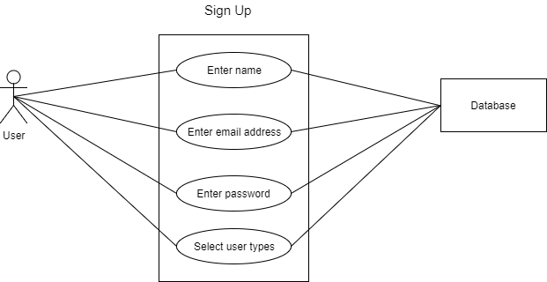

Figure 4: Level-1.1.1 Use Case Diagram

### **4.2.5 System Description from Level-1.1.2 use case:**

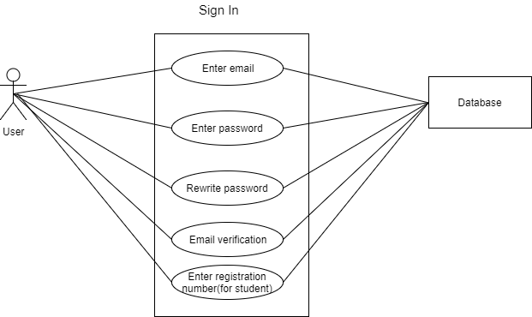

Figure 5: Level-1.1.2 Use Case Diagram

### **4.2.6 System Description from Level-2.1.a. use case:**

### 

Figure 6: Level-2.1.a. Use Case Diagram

### **4.2.6 System Description from Level-2.1.b. use case:**

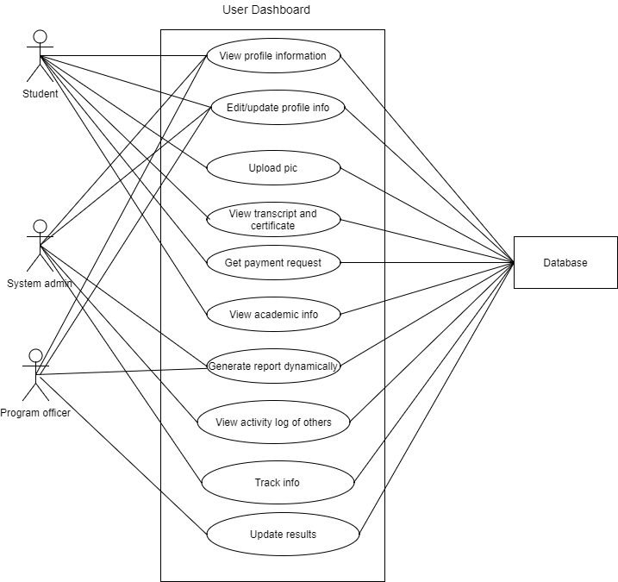

Figure 7: Level-2.1.a. Use Case Diagram